**Red Team:**

Ronald Stewart

Rashmi Sathiyanarayanan

Oyun Tsolmon

**Case Study:**

Willson Financial

**Milestone 3**

**Client report**:

How many clients have been added for each of the past six months?

* To get this information, we are retrieving the date the client was created in the format of YY-MM-DD. We also need to retrieve the count of client’s created in a specific month for the last six months to display all clients added each month for the last six months.
* We can retrieve the first name, last name and the date created from the date created is less than current date minus six months. This retrieves the clients added for the last six months.

**Transaction Report:**

How many clients have a high number (more than 10 a month) of transactions?

* To get this information, we first need to extract the month and year from the transaction date.
* We then need to group the transactions by account number, year, and month. After this we need to get the count of transactions for each group (account number, year, month).
* We then need to filter the above output to get the groups having count greater than 10 (for high number of transactions).
* Further we can create a view on the above output which now has fields (account number, year, month, count).
* We can then join this view with the accounts table based on account number to get the client ID.
* Finally, we can get the count of clients by getting the count of the above output.

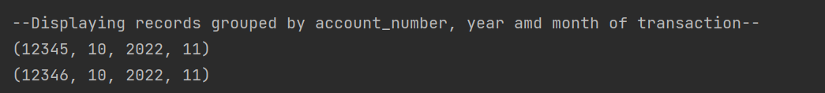

**Assets Report:**

What is the average amount of assets (in currency) for the entire client list?

* The first query in this script selects and displays all the data from the ‘assets’ table
* The output is organized by order of asset ID (PK) and prints the corresponding asset type, as well as the total amount
* Finally, we print the corresponding client ID (FK)
* The second query takes the average of all client assets and prints the result as the dollar amount

